Tea and Chat
Come and meet neighbours
and friends while enjoying
home made cakes,tea and coffee

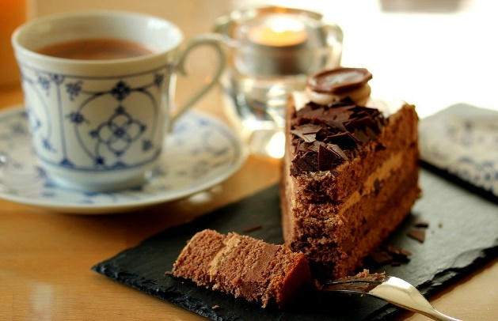

Kirby Misperton Village Hall
Thursday 30th September
Thursday 28th October
2.00-4.00pm

If you need a lift please contact
Jackie Cray 01653 669365
Or 07889 742973
jackiecray@hotmail.co.uk

